Decode the Chart — Answer Key
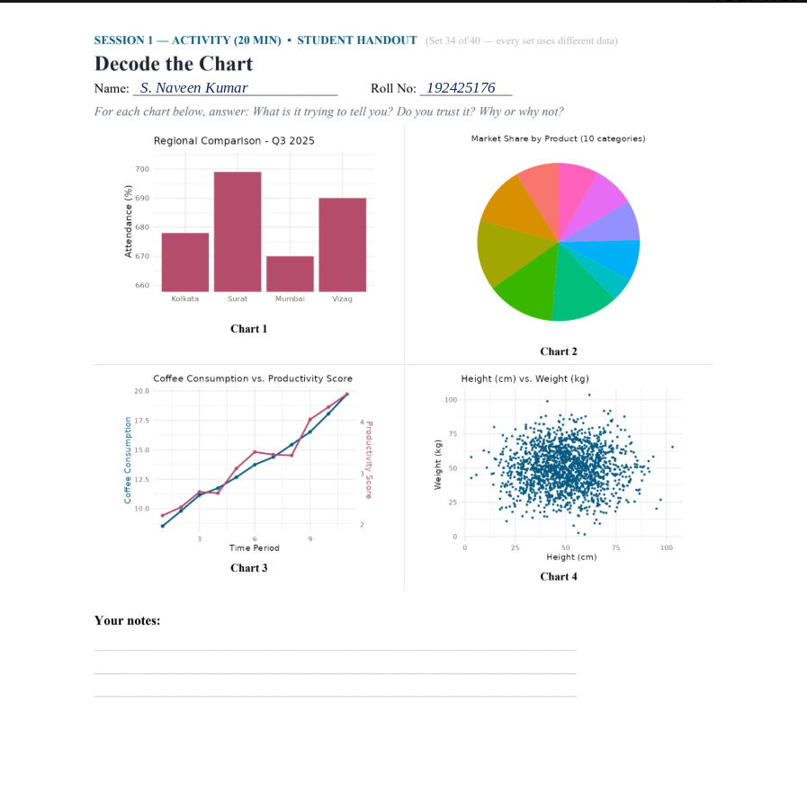
Session 1 Activity • Set 34 of 40 • Instructor Only

Student handout — Set 34


